Krugman Module 17 – Aggregate Demand
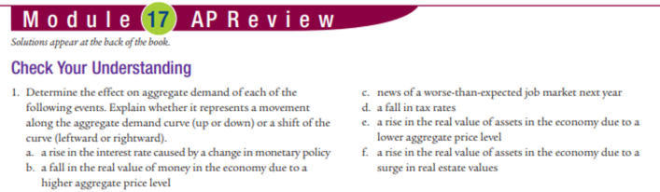
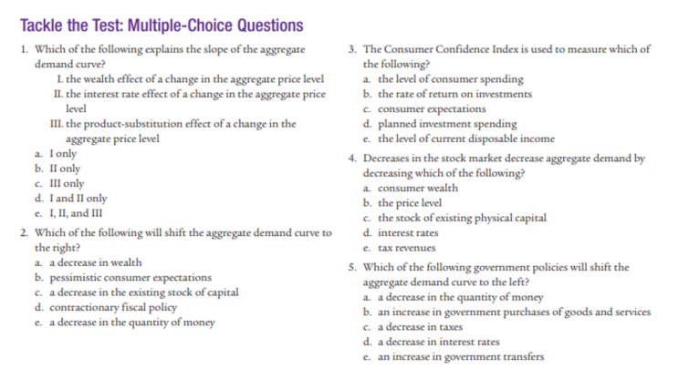
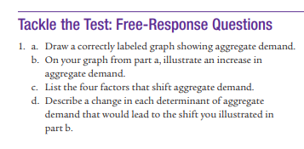
Answers:
Check Your Understanding:
1. a. shift of AD to left b. movement along c. shift of AD to left d. shift of AD to right e. movement down f. shift AD right
MC 1.d 2.d 3.c 4.a 5.a
Free Response:
2. wealth effect and IR effect

